(Approx. 401 words)

Ashampoo® PDF Pro 2 - Create and Open PDFs
By Jasmine Blue D’Katz, Lake County Area Computer Enthusiasts
www.lcace.org
jj1450xl (at) yahoo.com

I have been using Adobe Acrobat for several years to save documents to PDF format and create text-filled forms. Along with Acrobat, I’ve used a few other Optical Character Recognition OCR programs like ReadIRIS and ABBY FineReader PDF to read and convert typed, handwritten, or printed text images into machine-encoded text, whether from scanned documents, photo, or a document.

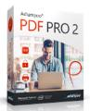
Recently, I have had problems with ReadIRIS giving me out-of-memory errors when I load a scanned file, so I decided to try something new. I ran across an article about Ashampoo PDF Pro 2, which claimed to be the complete solution to manage and edit your PDF documents. Like the other programs, I will be able to convert, edit, merge, and protect my PDFs, create perfectly sized documents that are readable on any device, and use encryption to protect them when needed.

I have used Adobe Acrobat to create a form for the club applications, and Ashampoo PDF Pro is ideal for creating fill-out forms. It takes only a few clicks to add interactive elements, like selection lists, checkboxes, or input fields, to my PDF form. These forms can then easily be filled out by anyone using a standard PDF reader.

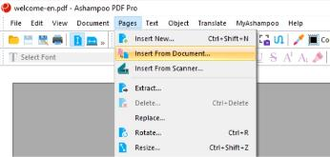

Convert documents into Word or other formats.

Another feature of Ashampoo Pro is the mature OCR engine that converts scanned characters into computer-editable text. The program also features seamless file exchange with Microsoft Word.

Although I have not found a need for the security features of encrypting a file, Ashampoo PDF Pro 2 uses up to 256bit AES encryption to allow PDF Pro 2 to secure my documents. Additional security can also be set by allowing a second (more secure) password to be set.

Ashampoo PDF Pro 2 for home use grants a single license that can be used for up to three PCs. The program was initially priced at $69.99, but I recently found it for $19.99 or at Amazon for $29.99.

This program has been easy to use with its well-designed interface. In addition, there is a great website that provided me with comprehensive Q&A, which has handled questions that I have had.

All in all, a great PDF editing tool at a great price!
Ashampoo® PDF Pro 2 - Best PDF Software & PDF-Editor for PDF files

